TODAY’S BIGGEST TRENDS: Mobile web, social media, real-time have forced us to rewire the way we think about and how we run our businesses. Consumers are creating a new digital culture, shifting business landscapes one tweet, text and chat at a time.
Networks have created an ever- expanding “web-i-fixation” in which everyday people believe their lives deserve a 24-hour broadcast. Broadcast what they do, who they meet, what they watch, what they eat, where they shop etc etc…So the question is has traditional marketing shifted? The answer is yes!
Traditional marketing consisted of 4Ps -product, promotion, price and place.
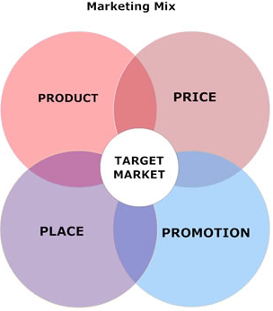

Today’ Marketing Mix has evolved and our ‘four Ps’ have been expanded to the ‘ seven Ps’ with the addition of ‘process’, ‘physical evidence’ and ‘people’.
Today Social media expansion is important because it provides a foundation for a broader / faster mindshare, along with supporting your search engine marketing objectives. You *can* convert traffic if you target your audience. Social media is evolving fast and marketers are starting to catch up.

